**JENKINS SETUP**

[**http://10.127.13.204:8080/**](http://10.127.13.204:8080/)

Install SSH Plug-In:

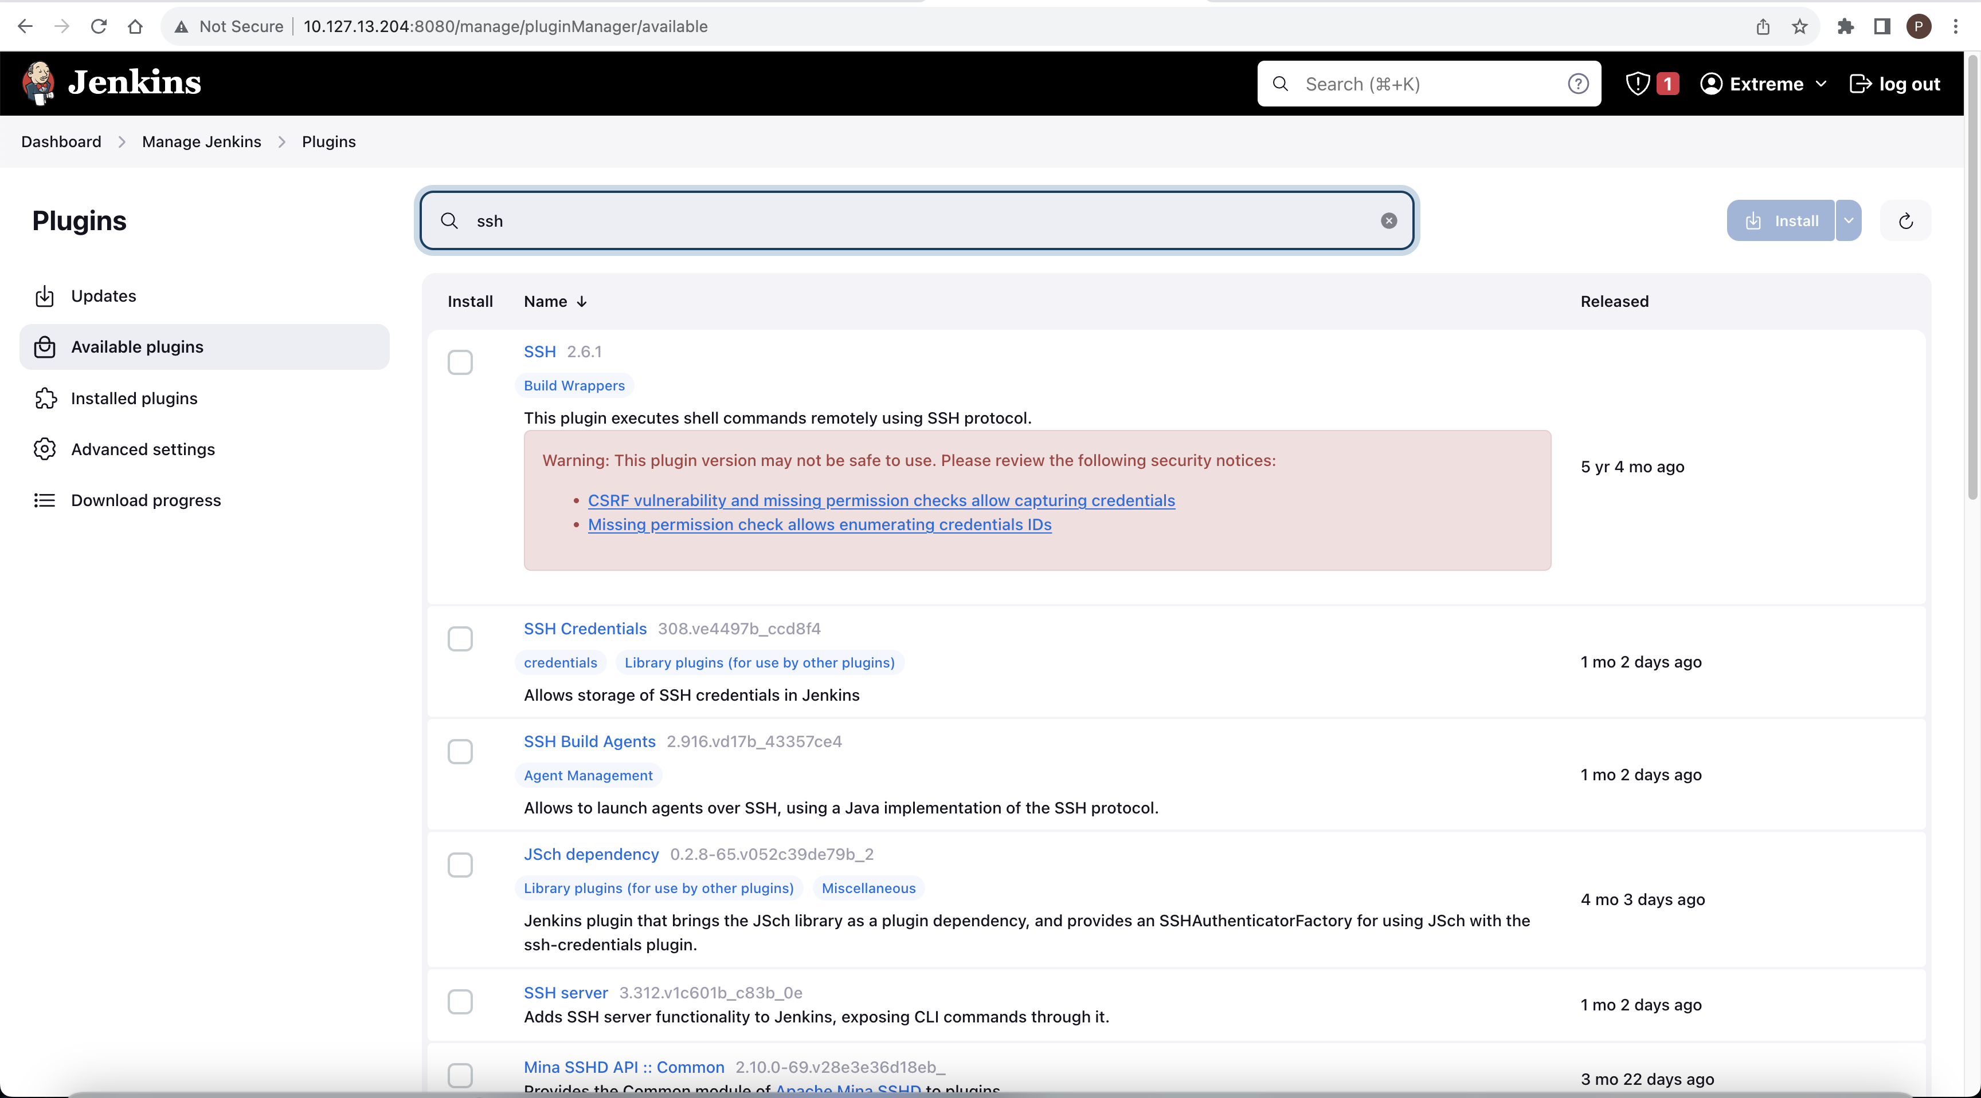

Navigate to Jenkins Dashboard> Manage Jenkins > Credentials > System > [Global credentials (unrestricted)](http://10.127.13.204:8080/manage/credentials/store/system/domain/_/) > Add Credentials

Navigate to Jenkins Dashboard> Manage Jenkins > System

Create folder and within it create freestyle project:

Configure the Jenkins job to run with parameters:

**Troubleshooting:**

Restarting Jenkins job:

**root@kubeworker**:**~**# docker ps -a | grep jenkins

5cee592b223d   **jenkins**/**jenkins**   "/usr/bin/tini -- /u…"   3 hours ago   Exited (5) 34 minutes ago             quirky_bardeen

**root@kubeworker**:**~**# docker start 5cee592b223d

5cee592b223d

**root@kubeworker**:**~**# docker ps -a | grep jenkins

5cee592b223d   **jenkins**/**jenkins**   "/usr/bin/tini -- /u…"   3 hours ago   Up 1 second              0.0.0.0:8080->8080/tcp, :::8080->8080/tcp, 0.0.0.0:50000->50000/tcp, :::50000->50000/tcp   quirky_bardeen